

*INTERNET TECHNOLOGIES LAB PROJECT REPORT ON*

**BUS TICKET BOOKING PORTAL**

*SUBMITTED TO*

**Department of Computer Science & Engineering**

*by*

Sahil Garg

Registration number : 160905058

Roll Number : 08

Semester – VII, Section - D

Jenit Jain

Registration number : 160905070

Roll Number : 09

Semester – VII, Section - D

*Under the guidance of*

ANCILLA PINTO

RAJASHREE K

Name & Signature of Evaluator 1 Name & Signature of Evaluator 2

(Oct 2019)

**1. Introduction**

This project is aimed at developing a bus booking portal that allows users to search and find buses and book tickets in buses that have vacancies available. The web application is developed using ASP.NET and C# and has several web pages with interactive user interface and design for easy access and navigation. The primary purpose of the website is the booking of bus tickets by the customers. The name of the website is called “BusBooking”.

The functionalities offered are based on the type of user that is accessing the webpage. There are two different type of users that can access this website –

1. Customer/User
2. Administrator

An administrator is provided with a special username and password for login. When an administrator logs in successfully after proper verification, he can maintain the details of all the buses that are currently going on different routes. He is provided with a page that allows him to add routes/buses, edit existing buses and delete buses that are actively functioning as of now. He can also view all the bookings that have taken place and are confirmed.

The customer on the other hand, has to sign up and make an account. After logging in with that account, the customer can get information regarding the buses he/she is interested in. One can search, sort and filter based on company of the bus, the date, time of arrival/departure, source location and destination location. The customer can then go ahead and make a booking for a specific number of seats if he/she is willing to make a purchase. Finally, the booking is confirmed and visible to the administrator. Customers can also view all the bookings that they have done till date by looking at the past trips page. They can also cancel bookings from here. Thus, the customer can search, sort, filter and view bus information, make bookings and also view and cancel prior bookings.

**2. Results and Screenshots**

The application was successfully developed with 6 different web pages having the functionalities as mentioned below –

1. MainPage.aspx : Provides features for sign up for new customers, login for customer and administrators
2. Book.aspx : Customers can search, sort and filter buses here, and make bookings
3. Confirm.aspx : Final confirmation of a successful or failed booking is given here
4. PastTrips.aspx : A customer can view past bookings and make cancellations
5. Admin_bus.aspx : Administrator can add new buses, edit and delete buses here
6. Admin_booking.aspx : Administrator can view all the bookings made by all customers here

The screenshots of all the pages with their functioning are as below –

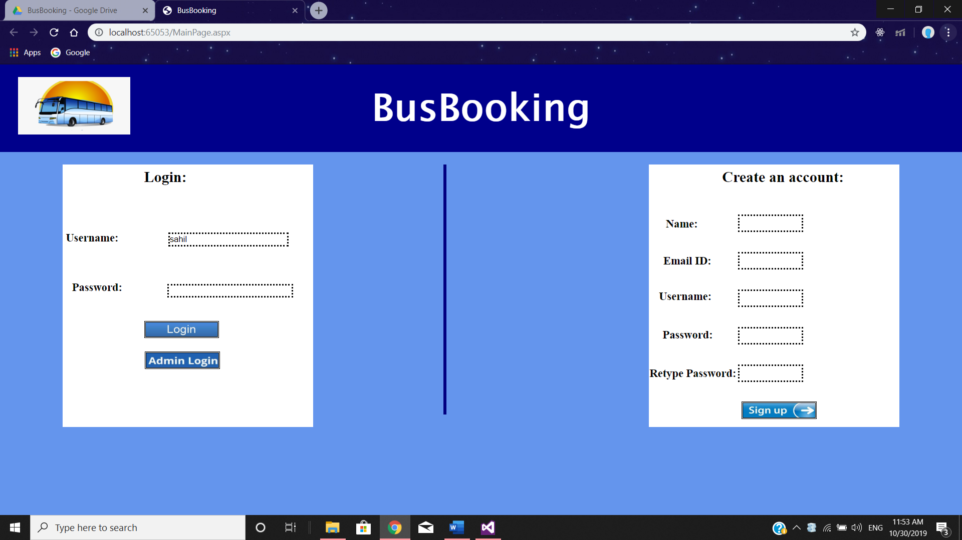

MainPage.aspx

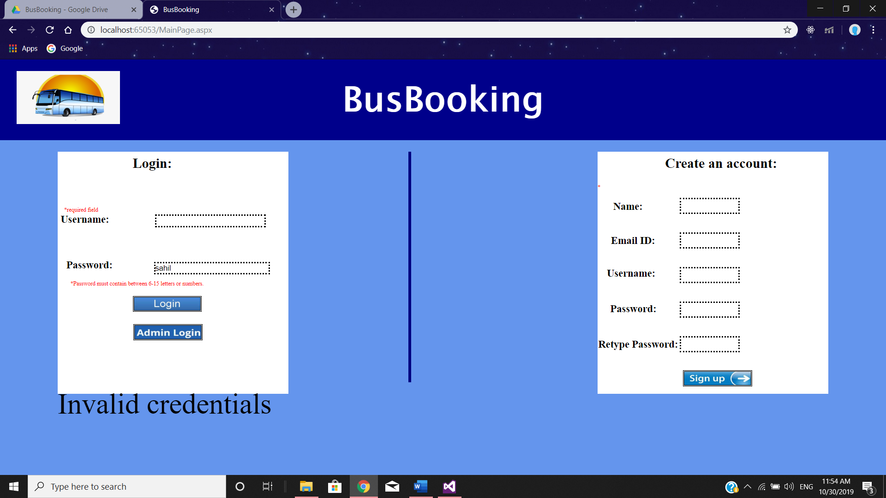

MainPage.aspx

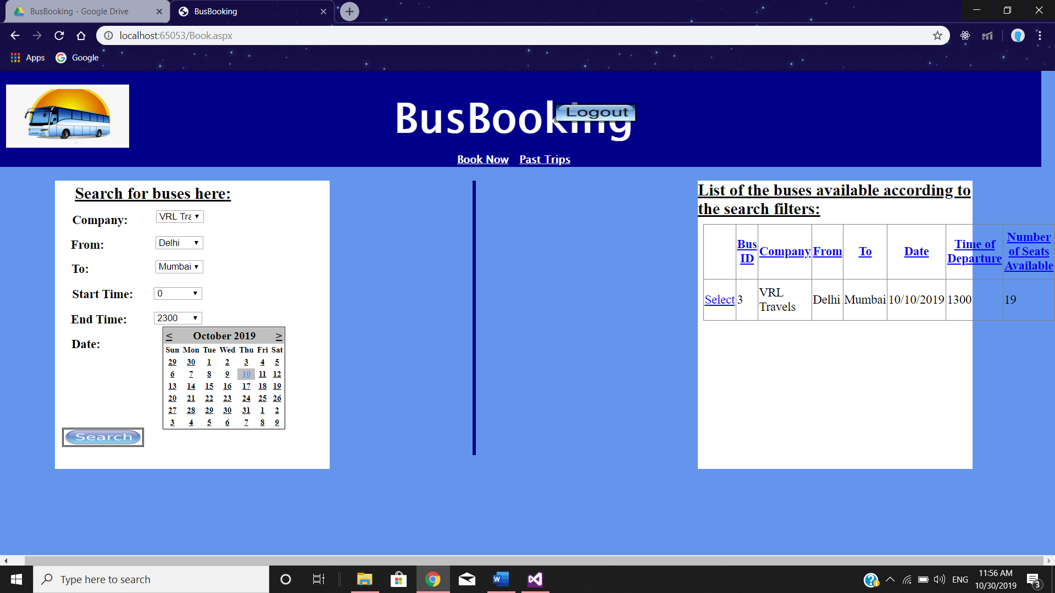

Book.aspx

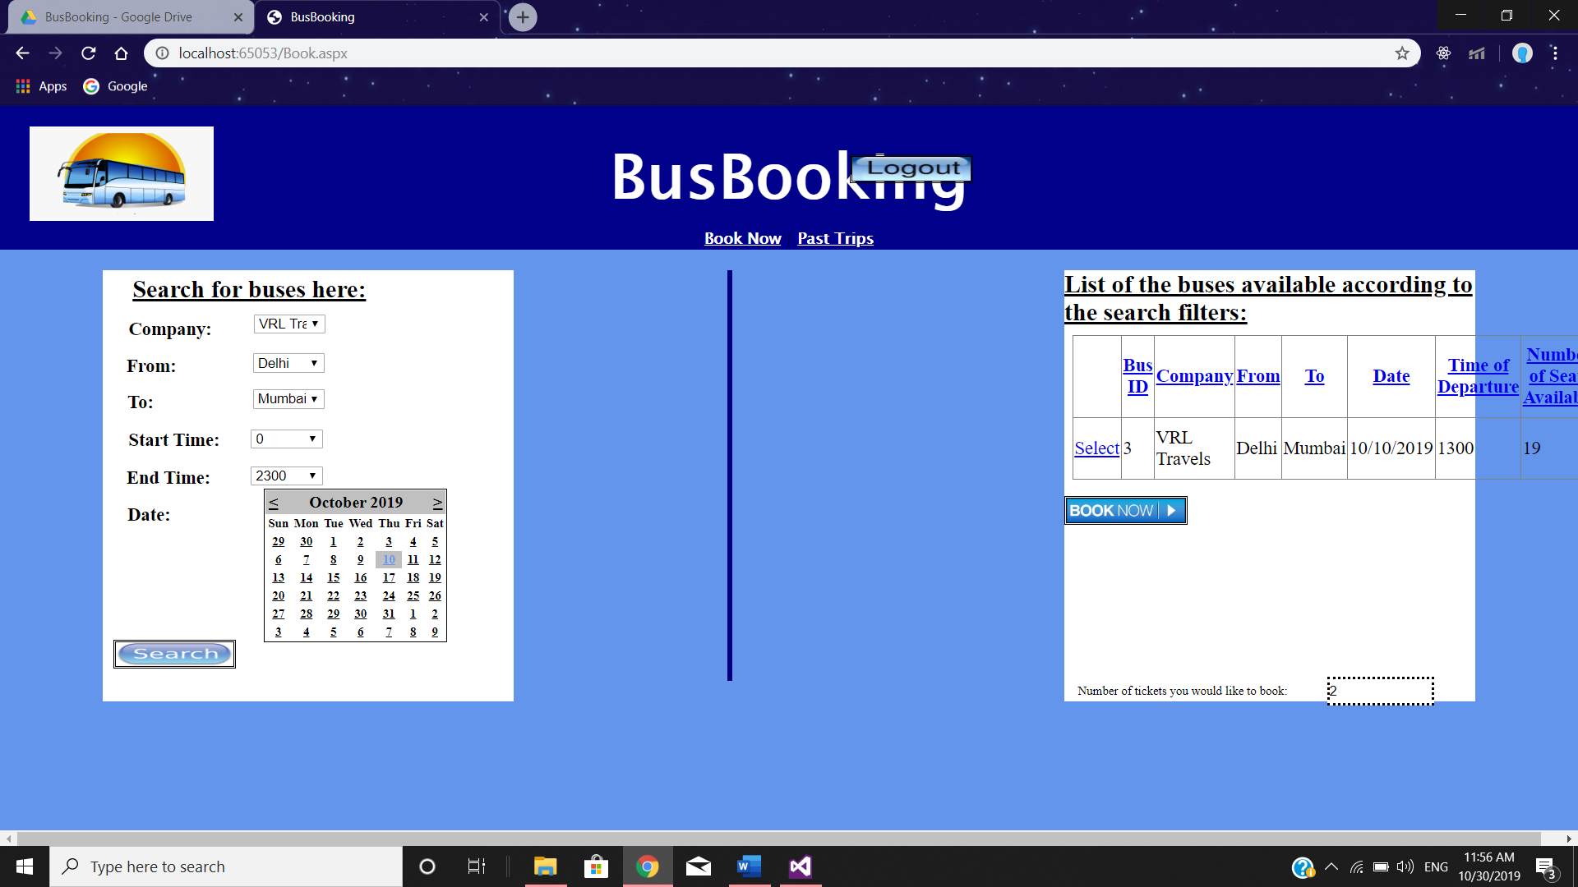

Book.aspx

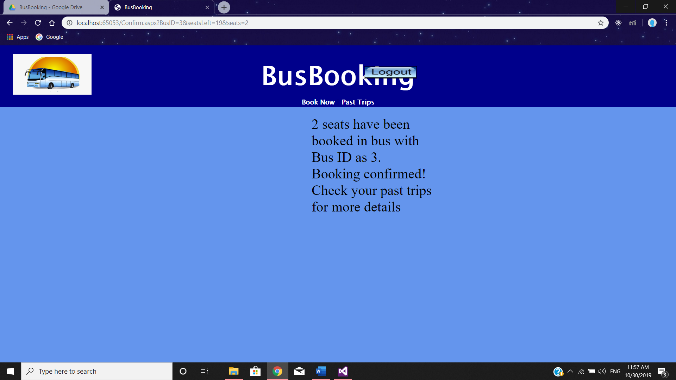

Confirm.aspx

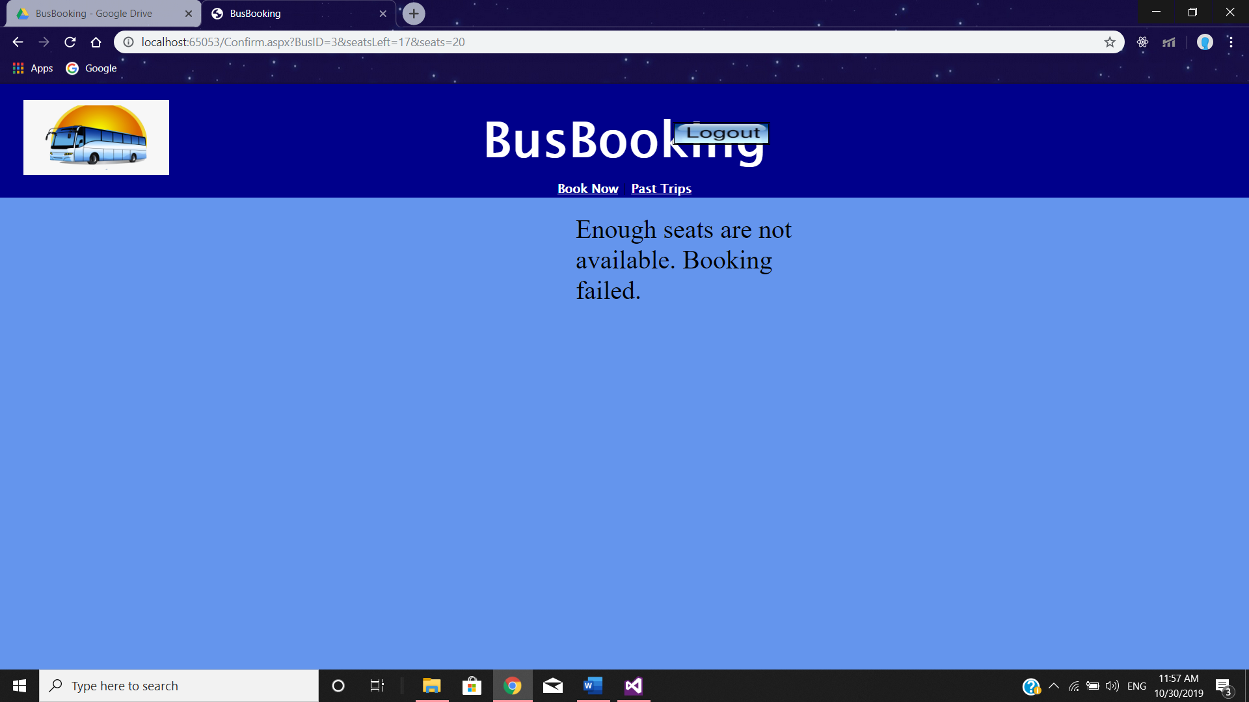

Confirm.aspx

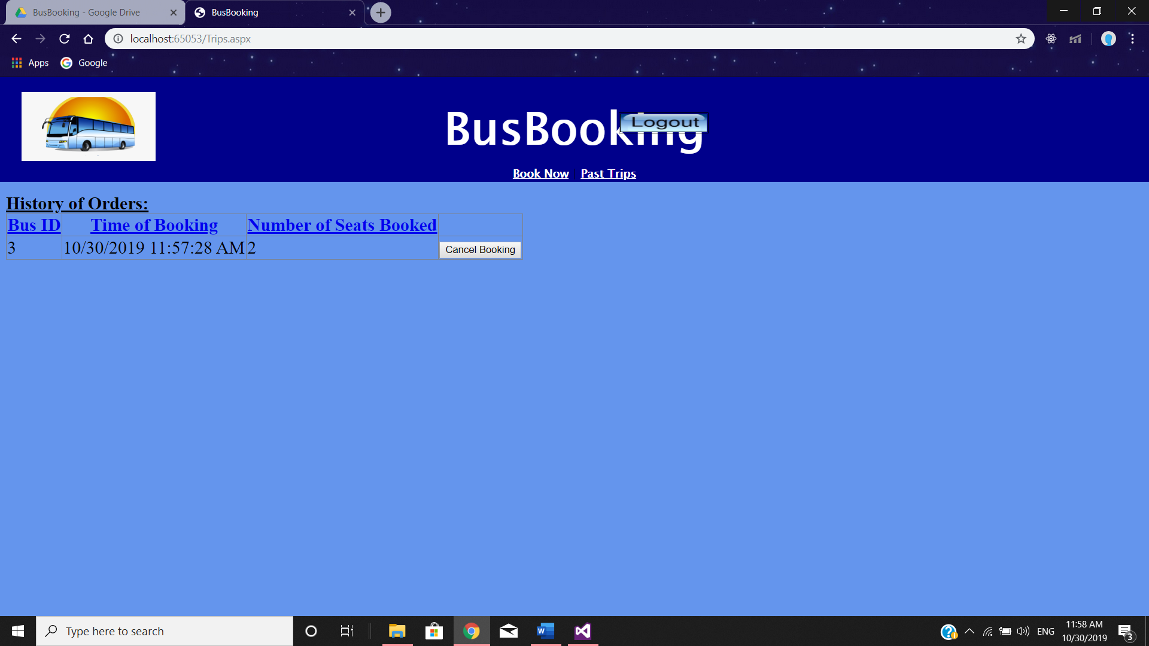

Trips.aspx - before cancelling booking

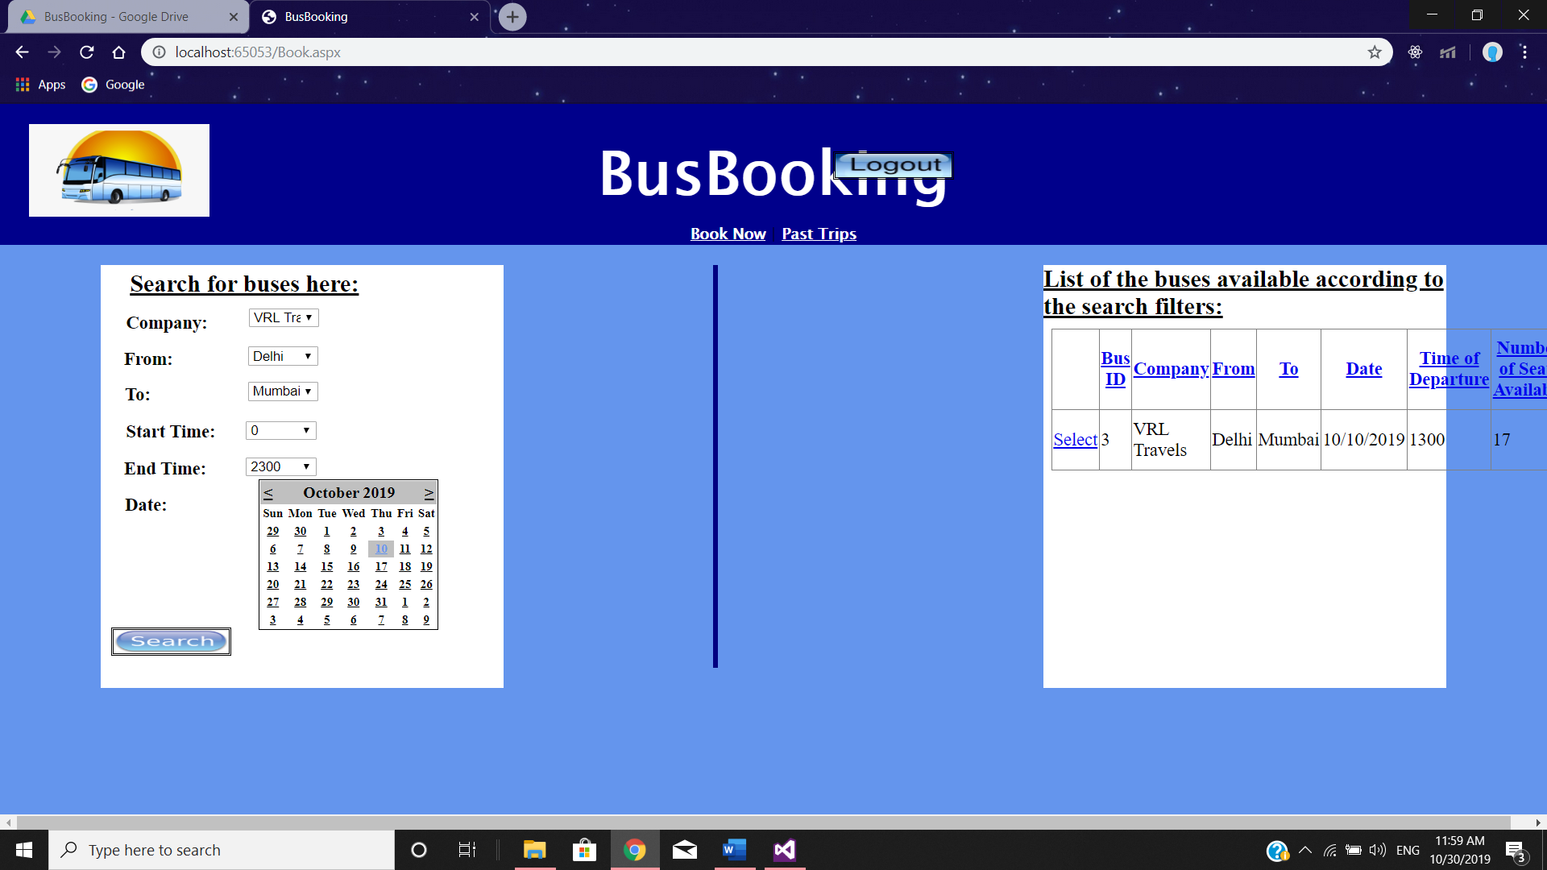

Book.aspx – Bus seats became 17 from 19 after booking 2 seats

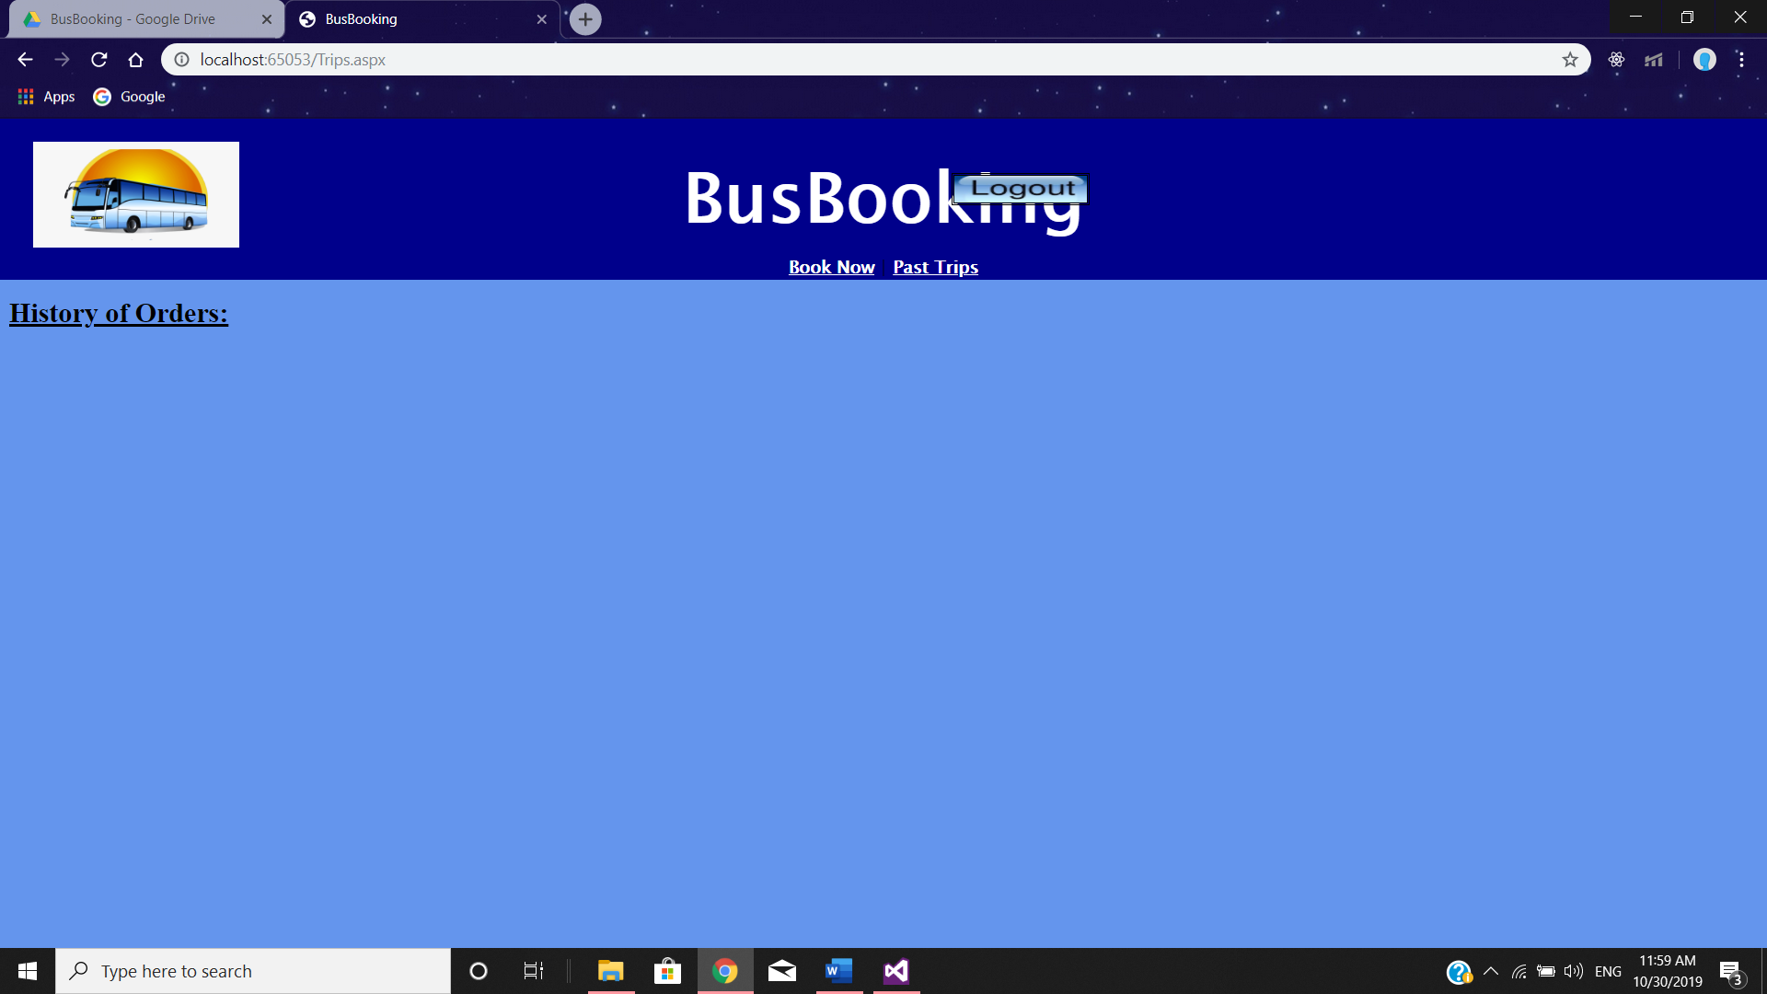

Trips.aspx – after cancelling booking

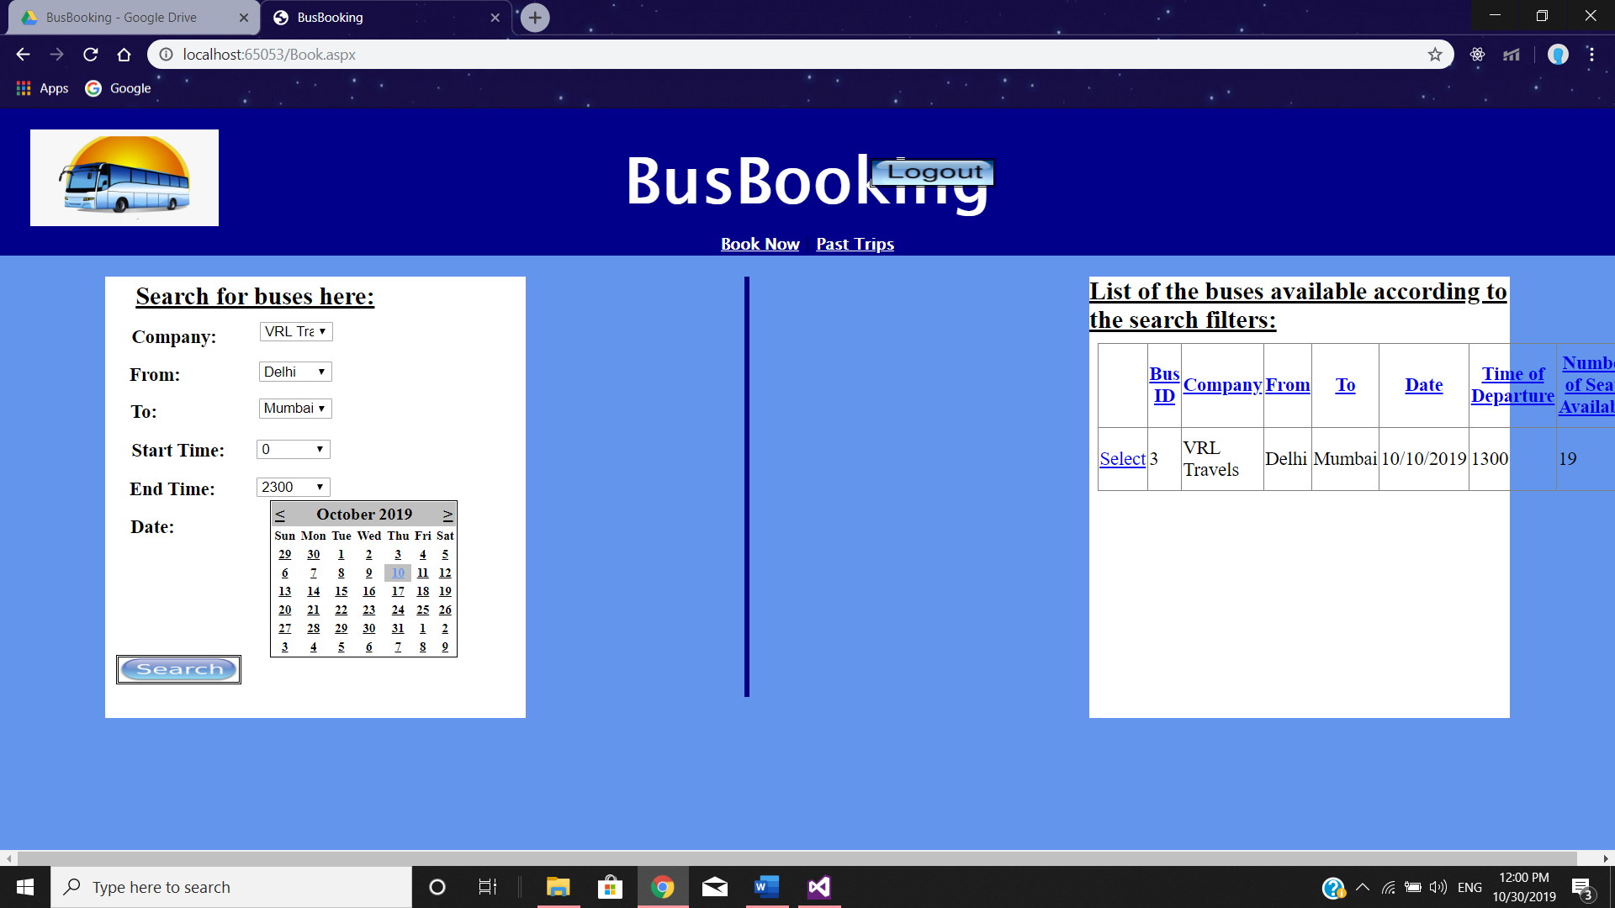

Book.aspx – Bus seats became 19 back from 17 after cancellation of 2 seats

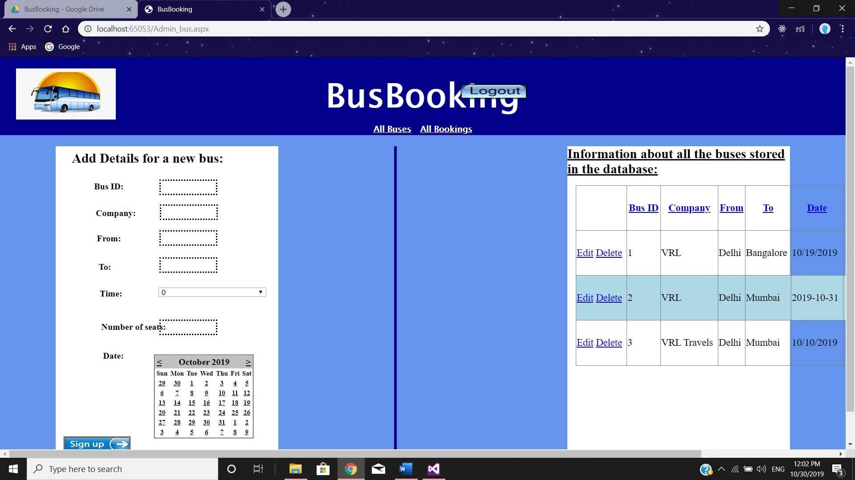

Admin_bus.aspx

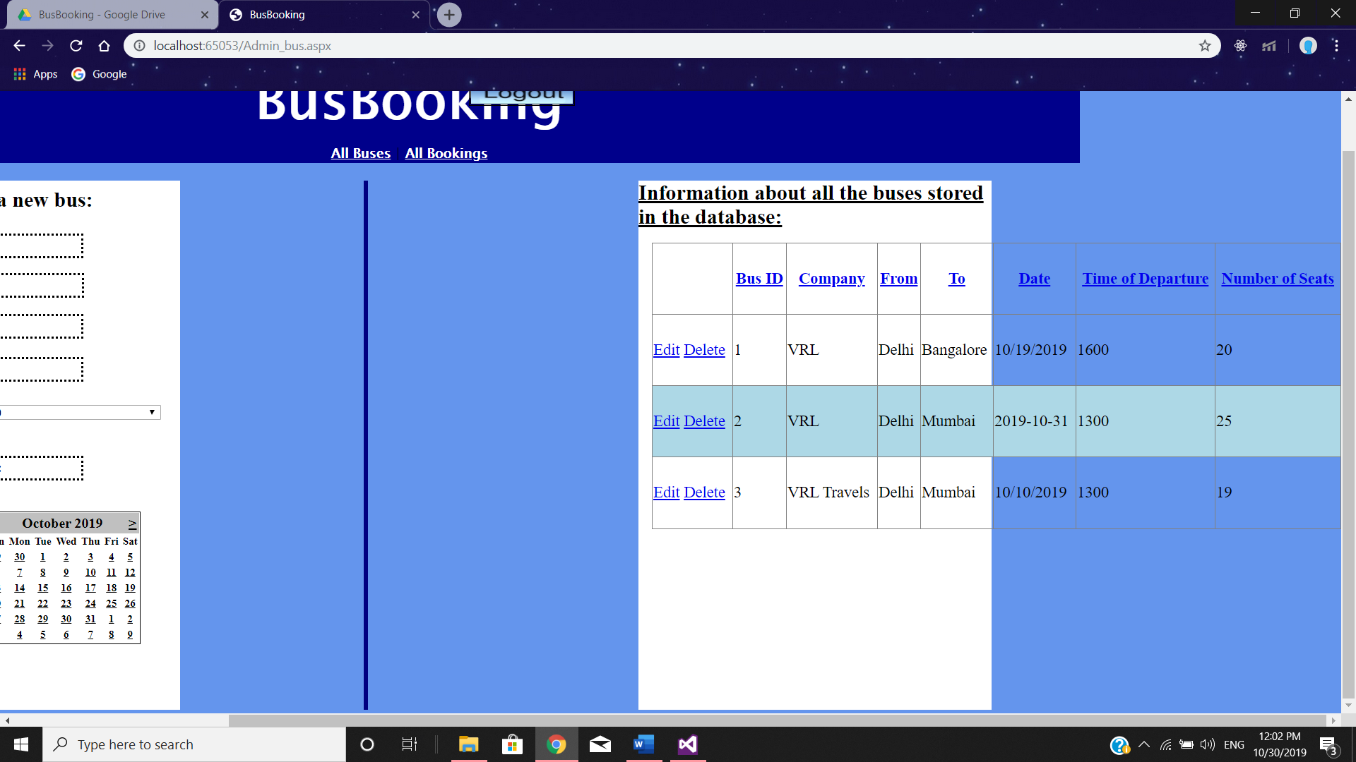

Admin_bus.aspx

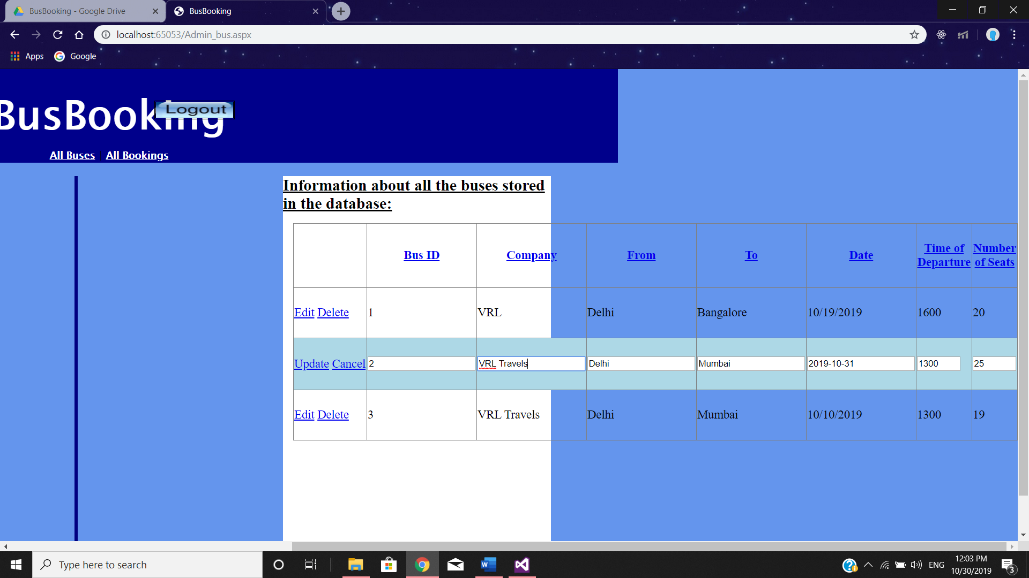

Admin_bus.aspx – Updating bus record

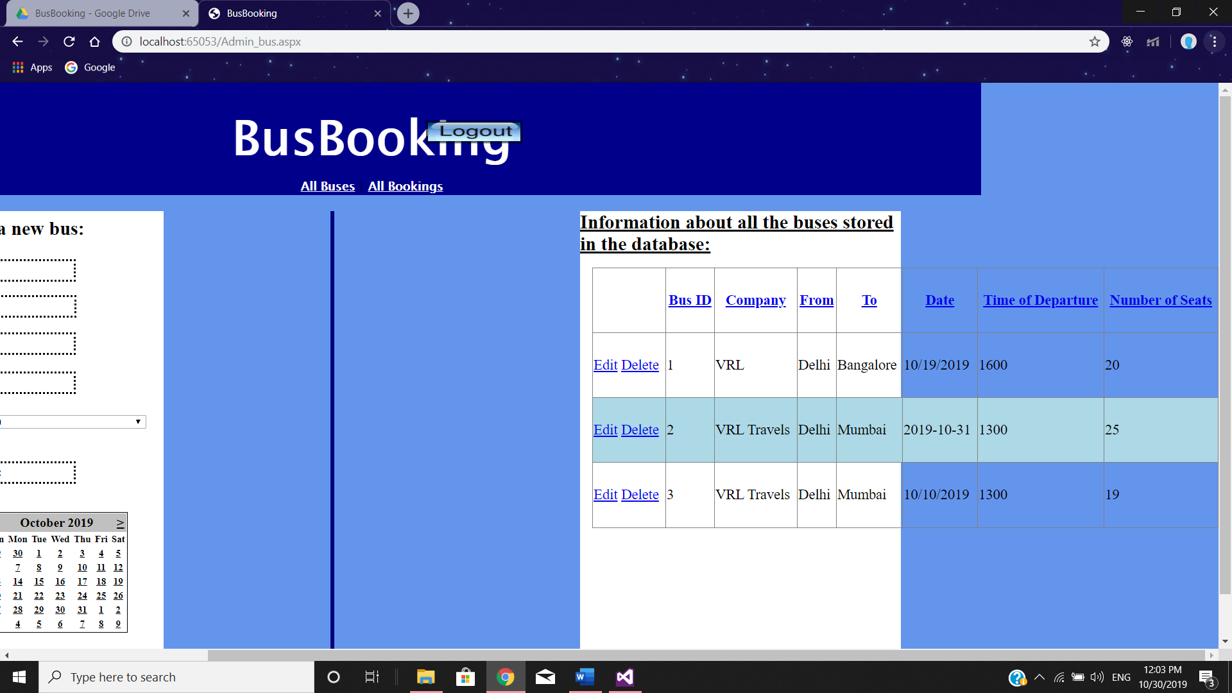

Admin_bus.aspx – Record updated

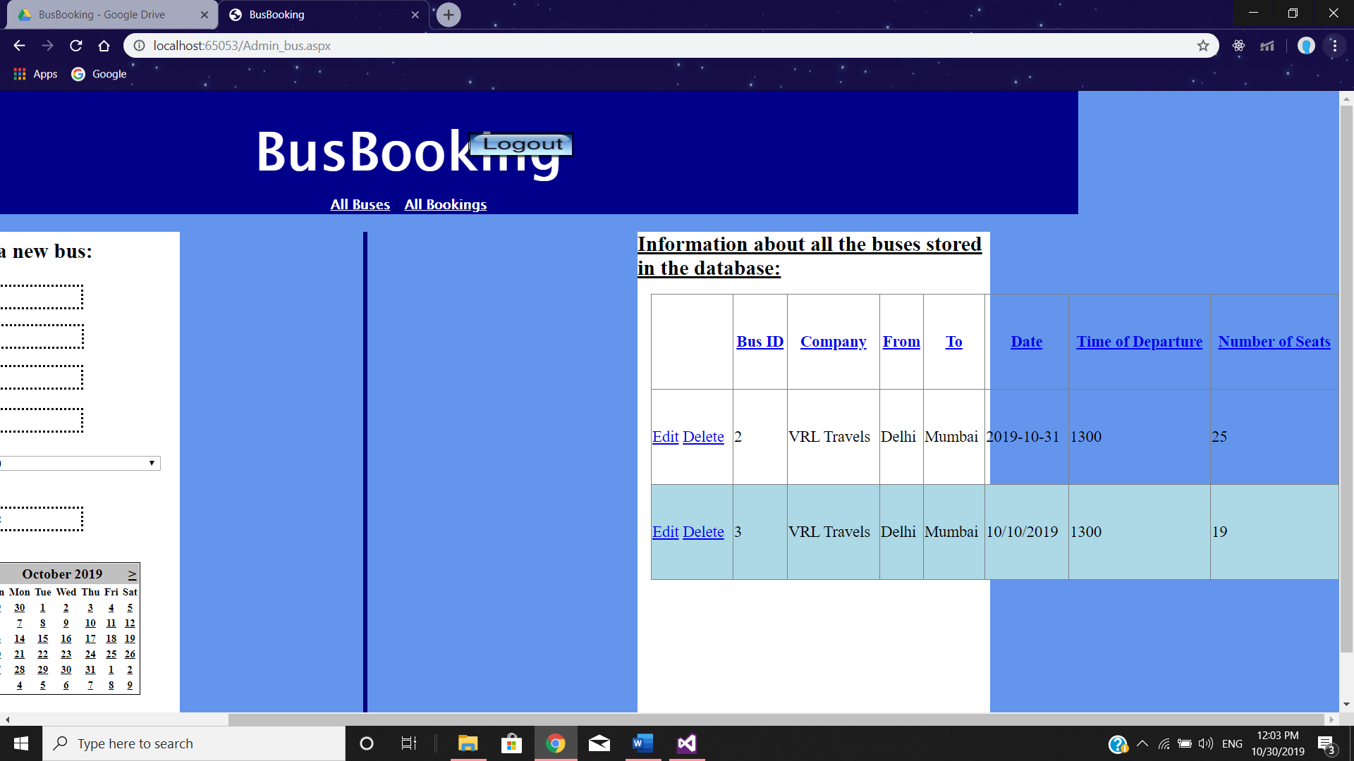

Admin_bus.aspx – Deleting bus record

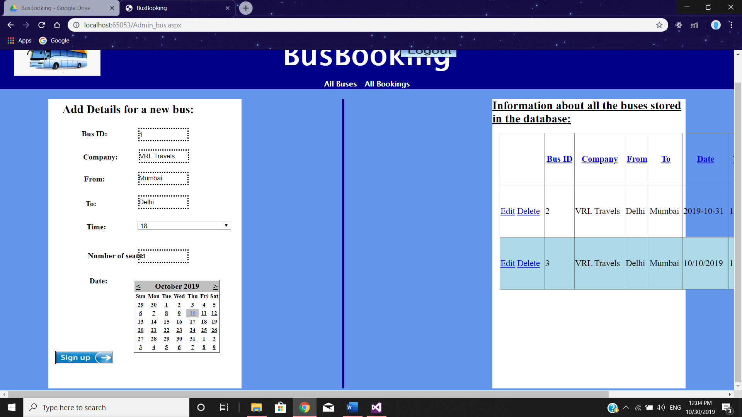

Admin_bus.aspx – Adding bus record

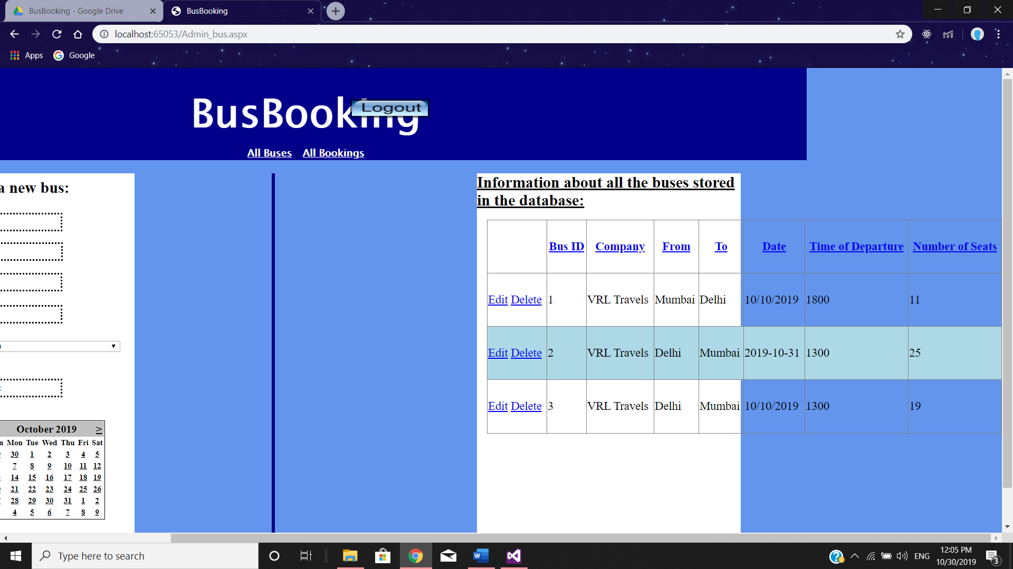

Admin_bus.aspx – Bus record Added

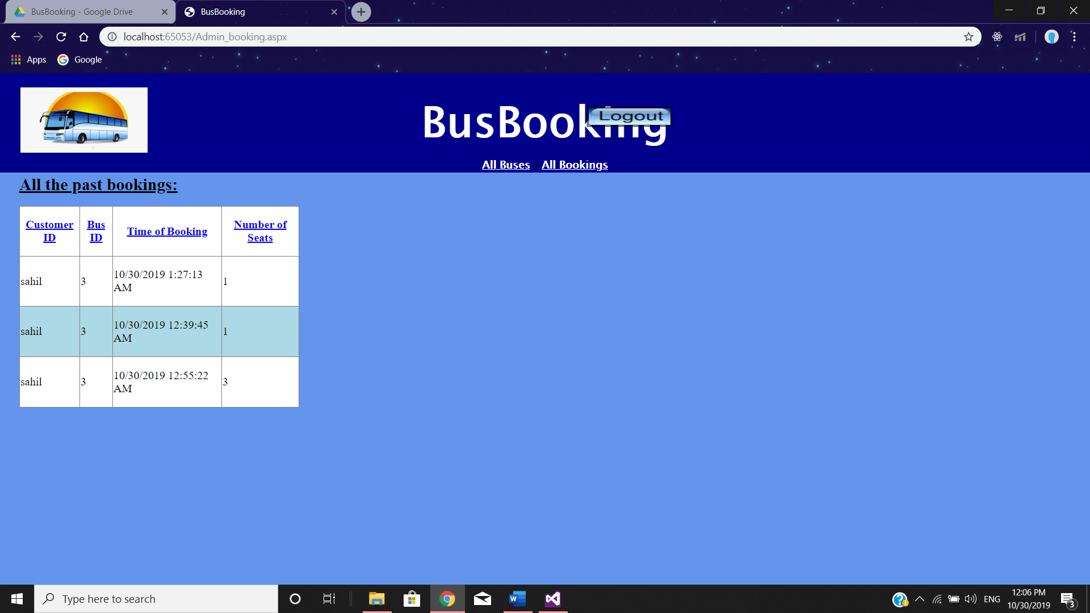

Admin_booking.aspx – View all bookings

**3. FRONT END CODE – ASPX FILES**

**MasterPage.master**

<%@ Master Language="C#" AutoEventWireup="true" CodeFile="MasterPage.master.cs" Inherits="MasterPage" %>

<!DOCTYPE html>

<html>

<head runat="server">

<link rel="stylesheet" href="stylesheet.css" />

<title>BusBooking</title>

</head>

<body class="body" >

<form id="form1" runat="server">

<div class="header" runat="server">

<br/>

<asp:Image runat="server" ImageUrl="~/bus.png" ImageAlign="Left" style="z-index: 1; left: 29px; top: 20px; position: absolute; height: 92px; width: 179px"/>

<asp:Label ID="Label1" runat="server" SkinID="main" > BusBooking </asp:Label>

<br/>

<asp:ContentPlaceHolder ID="ContentPlaceHolder2" runat="server">

</asp:ContentPlaceHolder>

<asp:ContentPlaceHolder ID="ContentPlaceHolder3" runat="server">

<asp:ImageButton ID="ImageButton1" PostBackUrl="~/MainPage.aspx" ImageUrl="~/logout.jpg" runat="server" Height="23px" style="z-index: 1; left: 827px; top: 47px; position: absolute" Width="115px"/>

</asp:ContentPlaceHolder>

</div>

<div>

<asp:ContentPlaceHolder ID="ContentPlaceHolder1" runat="server">

</asp:ContentPlaceHolder>

</div>

<br/>

<%--

<div class="footer">

<asp:Label ID="Label2" runat="server" Font-Size="7px" ForeColor="white">

<h2>IT_LAB Project, Bus Ticket Booking Website</h2>

<h2> Project By: Sahil Garg, Jenit Jain </h2>

<h2> Registration ID: 160905058, 160905070</h2>

<h2> Roll numbers: 8,9 </h2>

</asp:Label>

</div>

--%>

</form>

</body>

</html>

**MainPage.aspx**

<%@ Page Title="" Language="C#" MasterPageFile="~/MasterPage.master" AutoEventWireup="true" CodeFile="MainPage.aspx.cs" Inherits="MainPage" %>

<asp:Content ID="content2" ContentPlaceHolderID="ContentPlaceHolder2" runat="server" />

<asp:Content ID="content3" ContentPlaceHolderID="ContentPlaceHolder3" runat="server" />

<asp:Content ID="content1" ContentPlaceHolderID="ContentPlaceHolder1" runat="server">

<asp:Panel ID="Panel1" runat="server" CssClass="left">

<asp:Label ID="Label1" runat="server" Text="Login:" Font-Bold="true" Font-Size="X-Large" style="z-index: 1; left: 130px; top: 6px; position: absolute; height: 20px;" />

<br/>

<asp:Label ID="Label2" runat="server" Text="Username: " Font-Size="Large" Font-Bold="true" style="z-index: 1; left: 5px; top: 107px; position: absolute" /><asp:TextBox ID="username" runat="server" Width="188px" style="z-index: 1; left: 169px; top: 109px; position: absolute" ></asp:TextBox>

<asp:RequiredFieldValidator ID="RequiredFieldValidator1" ValidationGroup="G1" ControlToValidate="username" runat="server" ForeColor="Red" Text="*required field" ErrorMessage="*Username field cannot be left empty" style="z-index: 1; left: 11px; top: 95px; position: absolute"></asp:RequiredFieldValidator>

<br/>

<asp:Label ID="Label3" runat="server" Text="Password: " Font-Size="Large" Font-Bold="true" style="z-index: 1; left: 15px; top: 186px; position: absolute" /><asp:TextBox ID="password" runat="server" style="z-index: 1; left: 167px; top: 191px; position: absolute; width: 197px;" ></asp:TextBox>

<asp:RequiredFieldValidator ID="RequiredFieldValidator2" ValidationGroup="G1" ControlToValidate="password" runat="server" Text="*required field" ErrorMessage="*Password field cannot be left empty" style="z-index: 1; left: 20px; top: 168px; position: absolute"></asp:RequiredFieldValidator>

<br/>

<br/>

<asp:RegularExpressionValidator ValidationExpression="[\d\w]{6,15}" ValidationGroup="G1" ID="RegularExpressionValidator1" ForeColor="Red" ControlToValidate="password" runat="server" Text="*Password must contain between 6-15 letters or numbers." ErrorMessage="*Password must contain between 6-15 letters or numbers." style="z-index: 1; left: 22px; top: 223px; position: absolute"></asp:RegularExpressionValidator>

<br/>

<asp:ImageButton ID="login" OnClick="login_Click" ImageUrl="~/login.jpg" ValidationGroup="G1" runat="server" style="z-index: 1; left: 130px; top: 250px; position: absolute; height: 23px; width: 115px;" EnableTheming="false"/>

<asp:ImageButton ID="admin_login" OnClick="admin_login_Click" ImageUrl="~/admin.jpg" ValidationGroup="G1" runat="server" style="z-index: 1; left: 131px; top: 299px; position: absolute; height: 23px; width: 115px;" EnableTheming="false" />

<br/>

<asp:ValidationSummary ID="ValidationSummary1" ValidationGroup="G1" runat="server" />

<br/>

<asp:Label ID="Label10" runat="server" Text=""></asp:Label>

</asp:Panel>

<asp:Panel ID="Panel2" runat="server" CssClass="center">

<asp:Image ID="Image1" ImageUrl="~/line.jpg" runat="server" Height="400px" Width="5px" />

</asp:Panel>

<asp:Panel ID="Panel3" runat="server" CssClass="right">

<asp:Label ID="Label4" runat="server" Text="Create an account:" Font-Bold="true" Font-Size="X-Large" style="z-index: 1; left: 117px; top: 6px; position: absolute; height: 20px;" EnableTheming="false" />

<br/>

<asp:TextBox ID="TextBox3" runat="server" style="position: absolute; top:80px; left: 142px; height: 22px" EnableTheming="false"></asp:TextBox>

<br/>

<asp:TextBox ID="TextBox4" runat="server" style="position: absolute; top: 140px; left: 142px; height: 22px;" EnableTheming="false"></asp:TextBox>

<asp:RequiredFieldValidator ID="RequiredFieldValidator4" runat="server" ValidationGroup="G2" ControlToValidate="TextBox4" Text="*required field" ErrorMessage="*Email ID is required" style="z-index: 1; left: 26px; top: 131px; position: absolute"></asp:RequiredFieldValidator>

<br/>

<asp:Label ID="Label7" runat="server" Text="Username: " Font-Size="Large" Font-Bold="true" style="z-index: 1; left: 16px; top: 201px; position: absolute" /><asp:TextBox ID="TextBox1" runat="server" style="position: absolute; top: 200px; left: 142px; height: 22px;" EnableTheming="false"></asp:TextBox>

<asp:RequiredFieldValidator ID="RequiredFieldValidator5" runat="server" ControlToValidate="TextBox1" ErrorMessage="*Username is required" style="z-index: 1; left: 11px; top: 189px; position: absolute" Text="*required field" ValidationGroup="G2"></asp:RequiredFieldValidator>

<br/>

<asp:Label ID="Label8" runat="server" Font-Bold="true" Font-Size="Large" style="z-index: 1; left: 22px; top: 262px; position: absolute" Text="Password: " />

<asp:TextBox ID="TextBox2" runat="server" EnableTheming="false" style="position: absolute; top: 260px; left: 142px; height: 22px;"></asp:TextBox>

<asp:RegularExpressionValidator ID="RegularExpressionValidator3" runat="server" ControlToValidate="password" ErrorMessage="*Password must contain between 6-15 letters or numbers." ForeColor="Red" Text="*" ValidationExpression="[\d\w]{6,15}" ValidationGroup="G2"></asp:RegularExpressionValidator>

<asp:RequiredFieldValidator ID="RequiredFieldValidator3" runat="server" ControlToValidate="TextBox3" ErrorMessage="*Name is required" style="z-index: 1; left: 28px; top: 64px; position: absolute" Text="*required field" ValidationGroup="G2"></asp:RequiredFieldValidator>

<br/>

<asp:Label ID="Label9" runat="server" Font-Bold="true" Font-Size="Large" style="z-index: 1; left: 1px; top: 324px; position: absolute" Text="Retype Password: " />

<asp:TextBox ID="TextBox5" runat="server" EnableTheming="false" style="position: absolute;top: 320px; left: 142px; height: 22px"></asp:TextBox>

<asp:Label ID="Label5" runat="server" Font-Bold="true" Font-Size="Large" style="position: absolute; z-index: 1; left: 27px; top: 85px" Text="Name: " />

<br/>

<asp:ImageButton ValidationGroup="G2" ID="signup" runat="server" OnClick="signup_Click" ImageUrl="~/signup.jpg" style="z-index: 1; top: 379px; position: absolute; height: 23px; width: 115px; right: 132px" EnableTheming="false" />

<asp:RegularExpressionValidator ID="RegularExpressionValidator2" runat="server" ControlToValidate="TextBox4" ErrorMessage="*Email ID format is incorrect" style="z-index: 1; left: 24px; top: 171px; position: absolute" ValidationExpression=".*@.*" ValidationGroup="G2"></asp:RegularExpressionValidator>

<asp:Label ID="Label6" runat="server" Font-Bold="true" Font-Size="Large" style="z-index: 1; left: 23px; top: 144px; position: absolute" Text="Email ID:" />

<asp:CompareValidator ID="CompareValidator1" runat="server" ControlToCompare="TextBox2" ControlToValidate="TextBox5" ErrorMessage="*Passwords don't match" Operator="Equal" style="z-index: 1; left: 5px; top: 348px; position: absolute" Type="String" ValidationGroup="G2" ValueToCompare=""></asp:CompareValidator>

<asp:ValidationSummary ID="ValidationSummary2" ValidationGroup="G2" runat="server" style="z-index: 1; left: -15px; top: 363px; position: absolute; height: 28px; width: 387px" />

<asp:RequiredFieldValidator ID="RequiredFieldValidator6" runat="server" ControlToValidate="TextBox2" ErrorMessage="*Password is required" style="z-index: 1; left: 24px; top: 241px; position: absolute" Text="*required field" ValidationGroup="G2"></asp:RequiredFieldValidator>

</asp:Panel>

</asp:Content>

**Book.aspx**

<%@ Page Title="" Language="C#" MasterPageFile="~/MasterPage.master" AutoEventWireup="true" CodeFile="Book.aspx.cs" Inherits="Book" %>

<asp:Content runat="server" ID="content2" ContentPlaceHolderID="ContentPlaceHolder2" >

<asp:HyperLink ID="HyperLink1" SkinID="categories" runat="server" NavigateUrl="~/Book.aspx" >Book Now</asp:HyperLink> |

<asp:HyperLink ID="HyperLink2" SkinID="categories" runat="server" NavigateUrl="~/Trips.aspx">Past Trips</asp:HyperLink>

</asp:Content>

<asp:Content runat="server" ID="content1" ContentPlaceHolderID="ContentPlaceHolder1">

<asp:Panel ID="Panel1" runat="server" CssClass="left">

<asp:Label ID="Label1" runat="server" Text="Search for buses here:" Font-Bold="true" Font-Size="X-Large" Font-Underline="true" style="height: 20px; z-index: 1; left: 29px; top: 5px; position: absolute;" />

<br/><br/>

<asp:Label ID="Label2" runat="server" Text="Company: " Font-Size="Large" Font-Bold="true" style="z-index: 1; left: 25px; top: 47px; position: absolute" /><asp:DropDownList ID="companies" runat="server" style="z-index: 1; left: 147px; top: 43px; position: absolute"></asp:DropDownList>

<asp:RequiredFieldValidator ValidationGroup="G1" ForeColor="Red" ControlToValidate="companies" ID="RequiredFieldValidator1" runat="server" ErrorMessage="*Company name is required" style="z-index: 1; left: 24px; top: 35px; position: absolute"></asp:RequiredFieldValidator>

<br/>

<asp:Label ID="Label3" runat="server" Text="From: " Font-Size="Large" Font-Bold="true" style="z-index: 1; left: 23px; top: 83px; position: absolute" /><asp:DropDownList ID="source" runat="server" style="z-index: 1; left: 146px; top: 81px; position: absolute"></asp:DropDownList>

<asp:RequiredFieldValidator ValidationGroup="G1" ForeColor="Red" ControlToValidate="source" ID="RequiredFieldValidator2" runat="server" ErrorMessage="*Source city is required" style="z-index: 1; left: 26px; top: 72px; position: absolute"></asp:RequiredFieldValidator>

<br/>

<asp:Label ID="Label4" runat="server" Text="To: " Font-Size="Large" Font-Bold="true" style="z-index: 1; left: 24px; top: 118px; position: absolute; height: 20px; width: 36px" /><asp:DropDownList ID="destination" runat="server" style="z-index: 1; left: 146px; top: 116px; position: absolute"></asp:DropDownList>

<asp:RequiredFieldValidator ValidationGroup="G1" ForeColor="Red" ControlToValidate="destination" ID="RequiredFieldValidator3" runat="server" ErrorMessage="*Destination city is required" style="z-index: 1; left: 23px; top: 104px; position: absolute"></asp:RequiredFieldValidator>

<br/>

<asp:Label ID="Label6" runat="server" Font-Bold="true" Font-Size="Large" Text="Start Time: " style="z-index: 1; left: 25px; top: 155px; position: absolute" />

<asp:DropDownList ID="stime" runat="server" style="z-index: 1; left: 144px; top: 155px; position: absolute"></asp:DropDownList>

<asp:RequiredFieldValidator ValidationGroup="G1" ForeColor="Red" ControlToValidate="stime" ID="RequiredFieldValidator4" runat="server" ErrorMessage="*Start time is required" style="z-index: 1; left: 22px; top: 138px; position: absolute"></asp:RequiredFieldValidator>

<br/>

<asp:Label ID="Label7" runat="server" Text="End Time: " Font-Size="Large" Font-Bold="true" style="z-index: 1; left: 23px; top: 192px; position: absolute" /><asp:DropDownList ID="etime" runat="server" style="z-index: 1; left: 144px; top: 191px; position: absolute; margin-top: 0px;"></asp:DropDownList>

<asp:RequiredFieldValidator ValidationGroup="G1" ForeColor="Red" ControlToValidate="etime" ID="RequiredFieldValidator5" runat="server" ErrorMessage="*End time is required" style="z-index: 1; left: 24px; top: 179px; position: absolute"></asp:RequiredFieldValidator>

<br/>

<asp:Label ID="Label5" runat="server" Font-Bold="true" Font-Size="Large" style="margin-top: 11px; z-index: 1; left: 24px; top: 217px; position: absolute; right: 325px;" Text="Date: " />

<asp:Calendar ID="Calendar1" runat="server" style="z-index: 1; left: 157px; top: 213px; position: absolute; height: 70px; width: 150px"></asp:Calendar>

<br/>

<asp:ImageButton ID="search" PostBackUrl="~/Book.aspx" ValidationGroup="G1" runat="server" ImageUrl="~/search.png" style="z-index: 1; left: 10px; top: 360px; position: absolute; height: 23px; width: 115px;" BorderStyle="Double" />

<asp:ValidationSummary ID="ValidationSummary1" ValidationGroup="G1" runat="server" style="z-index: 1; left: -5px; top: 263px; position: absolute; height: 28px; width: 400px" />

</asp:Panel>

<asp:Panel ID="Panel2" runat="server" CssClass="center">

<asp:Image ID="Image1" ImageUrl="~/line.jpg" runat="server" Height="400px" Width="5px" />

</asp:Panel>

<asp:Panel ID="Panel3" runat="server" CssClass="right">

<asp:Label ID="Label8" runat="server" Text="List of the buses available according to the search filters:" Font-Size="X-Large" font-bold="true" Font-Underline="true" ></asp:Label>

<asp:GridView ID="GridView1" runat="server" AutoGenerateColumns="false" AllowPaging="true" PageSize="10" AutoGenerateSelectButton="true" CellSpacing="1" OnSelectedIndexChanging="selection_changed" sortExpression="id"

OnSelectedIndexChanged="GridView1_SelectedIndexChanged" DataSourceID ="SqlDataSource1" Font-Size="Large" AllowSorting="true" AlternatingRowStyle-BackColor="LightBlue" BorderStyle="Dashed" style="z-index: 1; left: 8px; top: 63px; position: absolute; height: 141px; width: 438px; margin-bottom: 0px">

<columns>

<asp:BoundField DataField="BusID" HeaderText="Bus ID" SortExpression="BusID"/>

<asp:BoundField DataField="Company" HeaderText="Company" SortExpression="Company" />

<asp:BoundField DataField="Source" HeaderText="From" SortExpression ="Source" />

<asp:BoundField DataField="Destination" HeaderText="To" SortExpression ="Destination"/>

<asp:BoundField DataField="Date" HeaderText="Date" SortExpression ="Date"/>

<asp:BoundField DataField="Time" HeaderText="Time of Departure" SortExpression="Time"/>

<asp:BoundField DataField="Seats" HeaderText="Number of Seats Available" SortExpression ="Seats"/>

</columns>

</asp:GridView>

<br/>

<asp:Label ID="seats" runat="server" Text="Number of tickets you would like to book: " style="z-index: 1; left: 13px; top: 403px; position: absolute"></asp:Label><asp:TextBox ID="num_seats" runat="server" style="z-index: 1; left: 256px; top: 396px; position: absolute; height: 22px"></asp:TextBox>

<br/>

<asp:ImageButton ID="book" ImageUrl="~/book.jpg" runat="server" OnClick="Book_Ticket" />

</asp:Panel>

<asp:SqlDataSource ID="SqlDataSource1" runat="server" ProviderName="System.Data.SqlClient" ConnectionString="<%$ connectionStrings:bus %>"

SelectCommand ="select * from Buses where Company = @company AND Source = @source AND Destination = @destn AND Time >= @start AND Time <= @end AND Date = @date ">

<SelectParameters>

<asp:ControlParameter ControlID="companies" Name ="company" PropertyName ="SelectedValue" />

<asp:ControlParameter ControlID="source" Name ="source" PropertyName ="SelectedValue" />

<asp:ControlParameter ControlID="destination" Name ="destn" PropertyName ="SelectedValue" />

<asp:ControlParameter ControlID="stime" Name ="start" PropertyName ="SelectedValue" />

<asp:ControlParameter ControlID="etime" Name ="end" PropertyName ="SelectedValue" />

<asp:ControlParameter ControlID="Calendar1" Name ="date" PropertyName ="SelectedDate" />

</SelectParameters>

</asp:SqlDataSource>

</asp:Content>

**Trips.aspx**

<%@ Page Title="" Language="C#" MasterPageFile="~/MasterPage.master" AutoEventWireup="true" CodeFile="Trips.aspx.cs" Inherits="Trips" %>

<asp:Content runat="server" ID="content2" ContentPlaceHolderID="ContentPlaceHolder2" >

<asp:HyperLink ID="HyperLink1" SkinID="categories" runat="server" NavigateUrl="~/Book.aspx" >Book Now</asp:HyperLink> |

<asp:HyperLink ID="HyperLink2" SkinID="categories" runat="server" NavigateUrl="~/Trips.aspx">Past Trips</asp:HyperLink>

</asp:Content>

<asp:Content ID="Content1" ContentPlaceHolderID="ContentPlaceHolder1" Runat="Server">

<asp:Panel ID="Panel1" runat="server">

<br />

<br />

<br />

<br />

<br />

<br />

<br />

<br />

<asp:Label ID="Label8" runat="server" Text="History of Orders:" Font-Size="X-Large" font-bold="true" Font-Underline="true" >

</asp:Label>

<asp:GridView ID="GridView1" runat="server" AutoGenerateColumns="false" AllowPaging="true" PageSize="10" CellSpacing="1"

DataKeyNames="Time" DataSourceID="SqlDataSource1" AllowSorting="true" AlternatingRowStyle-BackColor="LightBlue" BorderStyle="Dashed" Font-Size="X-Large" OnSelectedIndexChanged="GridView1_SelectedIndexChanged">

<columns>

<asp:BoundField DataField="BusID" HeaderText="Bus ID" SortExpression="BusID" />

<asp:BoundField DataField="Time" HeaderText="Time of Booking" SortExpression="Time" />

<asp:BoundField DataField="Seats" HeaderText="Number of Seats Booked" SortExpression="Seats" />

<asp:CommandField ShowSelectButton="true" SelectText="Cancel Booking" ButtonType="Button" />

</columns>

</asp:GridView>

<br/>

</asp:Panel>

<asp:SqlDataSource ID="SqlDataSource1" runat="server" ProviderName="System.Data.SqlClient" ConnectionString="<%$ connectionStrings:bus %>"

SelectCommand ="select * from Bookings where Username = @us">

<SelectParameters>

<asp:SessionParameter Name="us" SessionField="user" DefaultValue="Anonymous Buyer" Type="String"/>

</SelectParameters>

</asp:SqlDataSource>

</asp:Content>

**Admin_bus.aspx**

<%@ Page Title="" Language="C#" MasterPageFile="~/MasterPage.master" AutoEventWireup="true" CodeFile="Admin_bus.aspx.cs" Inherits="Admin_bus" %>

<asp:Content runat="server" ID="content2" ContentPlaceHolderID="ContentPlaceHolder2" >

<asp:HyperLink ID="HyperLink1" SkinID="categories" runat="server" NavigateUrl="~/Admin_bus.aspx" >All Buses</asp:HyperLink> |

<asp:HyperLink ID="HyperLink2" SkinID="categories" runat="server" NavigateUrl="~/Admin_booking.aspx">All Bookings</asp:HyperLink>

</asp:Content>

<asp:Content ID="Content1" ContentPlaceHolderID="ContentPlaceHolder1" Runat="Server">

<asp:Panel runat="server" CssClass="left" Height="600px">

<asp:Label ID="Label4" runat="server" Text="Add Details for a new bus:" Font-Bold="true" Font-Size="X-Large" style="z-index: 1; left: 29px; top: 8px; position: absolute; height: 20px;" EnableTheming="false" />

<br/>

<asp:Label ID="Label5" runat="server" Text="Bus ID: " Font-Size="Medium" Font-Bold="true" style="z-index: 1; left: 69px; top: 63px; position: absolute" /><asp:TextBox ID="id" runat="server" style="position: absolute; top:60px; left: 186px; height: 22px; margin-top: 0px;" EnableTheming="false"></asp:TextBox>

<asp:RequiredFieldValidator ValidationGroup="Insert" ForeColor="Red" ID="RequiredFieldValidator1" runat="server" ControlToValidate="id" ErrorMessage="*Bus ID is required" style="z-index: 1; left: 75px; top: 44px; position: absolute"></asp:RequiredFieldValidator>

<br/>

<asp:Label ID="Label6" runat="server" Text="Company:" Font-Size="Medium" Font-Bold="true" style="z-index: 1; left: 72px; top: 111px; position: absolute" /><asp:TextBox ID="company" runat="server" style="position: absolute; top: 105px; left: 187px; height: 22px;" EnableTheming="false"></asp:TextBox>

<asp:RequiredFieldValidator ValidationGroup="Insert" ForeColor="Red" ID="RequiredFieldValidator2" runat="server" ControlToValidate="company" ErrorMessage="*Company is required" style="z-index: 1; left: 76px; top: 95px; position: absolute"></asp:RequiredFieldValidator>

<br/>

<asp:Label ID="Label7" runat="server" Text="From: " Font-Size="Medium" Font-Bold="true" style="z-index: 1; left: 74px; top: 157px; position: absolute; height: 20px; width: 50px" /><asp:TextBox ID="source" runat="server" style="position: absolute; top: 151px; left: 186px; height: 22px;" EnableTheming="false"></asp:TextBox>

<asp:RequiredFieldValidator ValidationGroup="Insert" ForeColor="Red" ID="RequiredFieldValidator3" runat="server" ControlToValidate="source" ErrorMessage="*Source city is required" style="z-index: 1; left: 75px; top: 140px; position: absolute"></asp:RequiredFieldValidator>

<br/>

<asp:Label ID="Label1" runat="server" Text="To: " Font-Size="Medium" Font-Bold="true" style="z-index: 1; left: 77px; top: 208px; position: absolute; width: 27px" /><asp:TextBox ID="destination" runat="server" style="position: absolute; top: 200px; left: 186px; height: 22px;" EnableTheming="false"></asp:TextBox>

<asp:RequiredFieldValidator ValidationGroup="Insert" ForeColor="Red" ID="RequiredFieldValidator4" runat="server" ControlToValidate="destination" ErrorMessage="*Destination city is required" style="z-index: 1; left: 76px; top: 190px; position: absolute; height: 15px; width: 138px"></asp:RequiredFieldValidator>

<br/>

<asp:Label ID="Label2" runat="server" Text="Time: " Font-Size="Medium" Font-Bold="true" style="z-index: 1; left: 79px; top: 256px; position: absolute" />

<asp:RequiredFieldValidator ValidationGroup="Insert" ForeColor="Red" ID="RequiredFieldValidator5" runat="server" ControlToValidate="time" ErrorMessage="*Time is required" style="z-index: 1; left: 77px; top: 240px; position: absolute"></asp:RequiredFieldValidator>

<br/>

<asp:Label ID="Label3" runat="server" Text="Number of seats: " Font-Size="Medium" Font-Bold="true" style="z-index: 1; left: 82px; top: 316px; position: absolute" /><asp:TextBox ID="num_seats" runat="server" style="position: absolute; top: 312px; left: 186px; height: 22px;" EnableTheming="false"></asp:TextBox>

<asp:RequiredFieldValidator ValidationGroup="Insert" ForeColor="Red" ID="RequiredFieldValidator6" runat="server" ControlToValidate="num_seats" ErrorMessage="*Number of seats is required" style="z-index: 1; left: 83px; top: 296px; position: absolute"></asp:RequiredFieldValidator>

<asp:Label ID="Label9" runat="server" Text="Date: " Font-Size="Medium" Font-Bold="true" style="z-index: 1; left: 85px; top: 368px; position: absolute; height: 20px" />

<br/>

<asp:Calendar ID="Calendar1" runat="server" style="z-index: 1; left: 177px; top: 375px; position: absolute; height: 151px; width: 178px"></asp:Calendar>

<br/>

<asp:ImageButton ValidationGroup="Insert" ID="signup" OnClick="signup_Click" runat="server" ImageUrl="~/signup.jpg" style="z-index: 1; top: 522px; position: absolute; height: 23px; width: 115px; right: 266px" EnableTheming="false"/>

<asp:DropDownList ID="time" runat="server" style="z-index: 1; left: 185px; top: 254px; position: absolute; height: 17px; width: 193px" />

<asp:ValidationSummary ID="ValidationSummary1" ValidationGroup="Insert" runat="server" style="z-index: 1; left: -9px; top: 409px; position: absolute; height: 28px; width: 400px" />

</asp:Panel>

<asp:Panel ID="Panel3" runat="server" CssClass="center">

<asp:Image ID="Image1" ImageUrl="~/line.jpg" runat="server" Height="400px" Width="5px" />

</asp:Panel>

<asp:Panel ID="Panel1" runat="server" CssClass="center">

<asp:Image ID="Image2" ImageUrl="~/line.jpg" runat="server" Height="600px" Width="5px" />

</asp:Panel>

<asp:Panel ID="Panel2" runat="server" CssClass="right" Height="600px" >

<asp:Label ID="Label8" runat="server" Text="Information about all the buses stored in the database:" Font-Size="X-Large" font-bold="true" Font-Underline="true" ></asp:Label>

<asp:GridView ID="GridView1" runat="server" AutoGenerateColumns="false" AllowPaging="true" PageSize="10" AutoGenerateDeleteButton="true" AutoGenerateEditButton="true"

Font-Size ="Large" DataSourceID="SqlDataSource1" EnablePersistedSelection ="true" AllowSorting="true" DataKeyNames="BusID" AlternatingRowStyle-BackColor="LightBlue" BorderStyle="Dashed" style="z-index: 1; left: 15px; top: 70px; position: absolute; height: 325px; width: 781px">

<columns>

<asp:BoundField DataField="BusID" HeaderText="Bus ID" SortExpression="BusID"/>

<asp:BoundField DataField="Company" HeaderText="Company" SortExpression="Company" />

<asp:BoundField DataField="Source" HeaderText="From" SortExpression ="Source" />

<asp:BoundField DataField="Destination" HeaderText="To" SortExpression ="Destination"/>

<asp:BoundField DataField="Date" HeaderText="Date" SortExpression ="Date"/>

<asp:BoundField DataField="Time" HeaderText="Time of Departure" SortExpression="Time"/>

<asp:BoundField DataField="Seats" HeaderText="Number of Seats" SortExpression ="Seats"/>

</columns>

</asp:GridView>

<br/>

</asp:Panel>

<asp:SqlDataSource ID="SqlDataSource1" runat="server" ProviderName="System.Data.SqlClient" ConnectionString="<%$ connectionStrings:bus %>"

SelectCommand ="select * from Buses"

DeleteCommand ="delete from Buses where BusID = @BusID"

UpdateCommand ="update Buses set Company = @Company, Source = @Source, Destination=@Destination, Date=@Date,Time=@Time,Seats=@Seats where BusID = @BusID">

<DeleteParameters>

<asp:ControlParameter Name ="BusID" ControlID="GridView1" />

</DeleteParameters>

</asp:SqlDataSource>

</asp:Content>

**Admin_booking.aspx**

<%@ Page Title="" Language="C#" MasterPageFile="~/MasterPage.master" AutoEventWireup="true" CodeFile="Admin_booking.aspx.cs" Inherits="Admin_booking" %>

<asp:Content runat="server" ID="content2" ContentPlaceHolderID="ContentPlaceHolder2" >

<asp:HyperLink ID="HyperLink1" SkinID="categories" runat="server" NavigateUrl="~/Admin_bus.aspx" >All Buses</asp:HyperLink> |

<asp:HyperLink ID="HyperLink2" SkinID="categories" runat="server" NavigateUrl="~/Admin_booking.aspx">All Bookings</asp:HyperLink>

</asp:Content>

<asp:Content ID="Content1" ContentPlaceHolderID="ContentPlaceHolder1" Runat="Server">

<asp:Panel runat="server">

<asp:Label ID="Label8" runat="server" Text="All the past bookings:" Font-Size="X-Large" font-bold="true" Font-Underline="true" style="z-index: 1; left: 27px; top: 143px; position: absolute" ></asp:Label>

<asp:GridView ID="GridView1" runat="server" AutoGenerateColumns="false" AllowPaging="true" PageSize="10" CellSpacing="1"

DataSourceID="SqlDataSource1" AllowSorting="true" AlternatingRowStyle-BackColor="LightBlue" BackColor="White" BorderStyle="Dashed" style="z-index: 1; left: 27px; top: 187px; position: absolute; height: 284px; width: 395px">

<columns>

<asp:BoundField DataField="Username" HeaderText="Customer ID" SortExpression="Username"/>

<asp:BoundField DataField="BusID" HeaderText="Bus ID" SortExpression="BusID" />

<asp:BoundField DataField="Time" HeaderText="Time of Booking" SortExpression="Time" />

<asp:BoundField DataField="Seats" HeaderText="Number of Seats" SortExpression="Seats" />

</columns>

</asp:GridView>

</asp:Panel>

<asp:SqlDataSource ID="SqlDataSource1" runat="server" ProviderName="System.Data.SqlClient" ConnectionString="<%$ connectionStrings:bus %>"

SelectCommand ="select * from Bookings">

</asp:SqlDataSource>

</asp:Content>

**Confirm.aspx**

<%@ Page Title="" Language="C#" MasterPageFile="~/MasterPage.master" AutoEventWireup="true" CodeFile="Confirm.aspx.cs" Inherits="_Default" %>

<asp:Content runat="server" ID="content3" ContentPlaceHolderID="ContentPlaceHolder2" >

<asp:HyperLink ID="HyperLink1" SkinID="categories" runat="server" NavigateUrl="~/Book.aspx" >Book Now</asp:HyperLink> |

<asp:HyperLink ID="HyperLink2" SkinID="categories" runat="server" NavigateUrl="~/Trips.aspx">Past Trips</asp:HyperLink>

</asp:Content>

<asp:Content ID="Content2" ContentPlaceHolderID="ContentPlaceHolder1" Runat="Server">

<asp:Panel ID="Panel1" runat="server" CssClass="center">

<asp:Label ID ="label1" Text ="Confirmation" runat="server" Font-Size="XX-Large"></asp:Label>

</asp:Panel>

</asp:Content>

**Themes – Main Theme = first.skin**

<asp:Image ImageUrl="~/bus.jpeg" runat="server" SkinID="image1" Height="120px" Width="160px" />

<asp:label runat="server" SkinID="main" Font-Size="60px" ForeColor="White" Font-Bold="true" />

<asp:HyperLink runat="server" SkinID="categories" Font-Size="15px" ForeColor="White" Font-Bold="true" Font-Underline="true" />

<asp:TextBox runat="server" width="100px" BorderStyle="Dotted" BorderWidth="2px" />

<asp:Calendar runat="server" BackColor="white" ForeColor="Black" BorderColor="Black" BorderStyle="solid"

CellSpacing="1" Font-Size="9pt" Height="75px" width="150px" SelectionMode="Day">

<SelectedDayStyle Font-Bold="true" ForeColor="cornflowerblue" />

<DayStyle Font-Bold="true" />

<DayHeaderStyle Font-Bold="true" height="8pt" />

<TitleStyle BorderStyle="None" Font-Bold="true" Font-Size="12pt" height="12pt" />

</asp:Calendar>

<asp:RequiredFieldValidator runat="server" font-size="10px" ForeColor="Red" />

<asp:RegularExpressionValidator runat="server" font-size="10px" ForeColor="Red" />

<asp:CompareValidator runat="server" font-size="10px" ForeColor="Red" />

<asp:ImageButton runat="server" style="z-index: 1; top: 220px; position: absolute; height: 23px; width: 115px;" BorderStyle="Double" />

<asp:DropDownList runat="server" Width="70px"/>

<asp:ValidationSummary runat="server" font-size="10px" ForeColor="Red" ShowSummary="true" Visible="true" DisplayMode="BulletList" />

**Stylesheet.css**

.header{

top: 0px;

left:0px;

right:0px;

height:140px;

position:absolute;

text-align: center;

background-color: darkblue;

font-family:'Lucida Sans', 'Lucida Sans Regular', 'Lucida Grande', 'Lucida Sans Unicode', Geneva, Verdana, sans-serif

}

.footer {

bottom: 0px;

left: 0px;

right: 0px;

height: 60 px;

position: absolute;

text-align: center;

margin-top:50px;

font-size: 5px;

background-color: darkblue;

font-family: 'Lucida Sans', 'Lucida Sans Regular', 'Lucida Grande', 'Lucida Sans Unicode', Geneva, Verdana, sans-serif

}

.left {

position: absolute;

top: 160px;

left: 100px;

width: 400px;

height: 420px;

font-size: 50px;

font-family: 'Lucida Sans', 'Lucida Sans Regular', 'Lucida Grande', 'Lucida Sans Unicode', Geneva, Verdana, sans-serif font-size: 50px;

background-color: white;

}

.body{

background-color:cornflowerblue;

}

.center{

position:absolute;

top:160px;

margin-left: 700px;

margin-right: 530px;

}

.right {

position: absolute;

background-color: white;

top: 160px;

height: 420px;

right: 100px;

width: 400px;

font-family: 'Lucida Sans', 'Lucida Sans Regular', 'Lucida Grande', 'Lucida Sans Unicode', Geneva, Verdana, sans-serif width: 400px;

font-size: 12px;

}

**Web.config file**

<?xml version="1.0"?>

<configuration>

<connectionStrings>

<add name="bus" connectionString="Data Source=(localdb)\MSSQLlocalDB;Initial Catalog=Bookings;Integrated Security=True"/>

</connectionStrings>

<appSettings>

<add key="ValidationSettings:UnobtrusiveValidationMode" value="None" />

</appSettings>

<system.web>

<pages styleSheetTheme="main" />

<compilation debug="true" targetFramework="4.5.2" />

<httpRuntime targetFramework="4.5.2" />

</system.web>

</configuration>

**4. CODE FILES (CODE BEHIND)**

**MasterPage.master.cs**

using System;

using System.Collections.Generic;

using System.Linq;

using System.Web;

using System.Web.UI;

using System.Web.UI.WebControls;

public partial class MasterPage : System.Web.UI.MasterPage

{

protected void Page_Load(object sender, EventArgs e)

{

}

}

**MainPage.aspx.cs**

using System;

using System.Collections.Generic;

using System.Data.SqlClient;

using System.Linq;

using System.Web;

using System.Web.UI;

using System.Web.UI.WebControls;

public partial class MainPage : System.Web.UI.Page

{

string conn = System.Web.Configuration.WebConfigurationManager.ConnectionStrings["bus"].ConnectionString ;

protected void Page_Load(object sender, EventArgs e)

{

if (!IsPostBack)

{

HttpCookie cookie = Request.Cookies["user"];

if (cookie != null)

username.Text = cookie["username"];

}

}

protected void signup_Click(object sender, ImageClickEventArgs e)

{

using (SqlConnection con = new SqlConnection(conn))

{

using(SqlCommand cmd = new SqlCommand())

{

cmd.Connection = con;

cmd.CommandText = "Insert into Users values (@name,@email,@user,@pass)";

cmd.Parameters.AddWithValue("@name", TextBox3.Text);

cmd.Parameters.AddWithValue("@email", TextBox4.Text);

cmd.Parameters.AddWithValue("@user", TextBox1.Text);

cmd.Parameters.AddWithValue("@pass", TextBox2.Text);

con.Open();

cmd.ExecuteNonQuery();

Label10.Text = "Successfully Registered!";

TextBox1.Text = "";

TextBox2.Text = "";

TextBox3.Text = "";

TextBox4.Text = "";

TextBox5.Text = "";

}

}

}

protected void login_Click(object sender, ImageClickEventArgs e)

{

string pass = "";

using (SqlConnection con = new SqlConnection(conn))

{

using (SqlCommand cmd = new SqlCommand())

{

cmd.Connection = con;

cmd.CommandText = "select Password from Users where Username = @user";

cmd.Parameters.AddWithValue("@user", username.Text);

con.Open();

SqlDataReader reader = cmd.ExecuteReader();

if(reader.Read())

pass = (string)reader["Password"];

else

{

Label10.Text = "Invalid credentials";

return;

}

}

}

if (pass.Equals(password.Text))

{

HttpCookie cookie = new HttpCookie("user");

cookie["username"] = username.Text;

cookie.Expires = DateTime.Now.AddYears(2);

Response.Cookies.Clear();

Response.Cookies.Add(cookie);

Session["user"] = username.Text;

Response.Redirect("Book.aspx");

}

else

{

Label10.Text = "Invalid credentials";

}

}

protected void admin_login_Click(object sender, ImageClickEventArgs e)

{

if(username.Text.Equals("admin") && password.Text.Equals("admin123")){

Response.Redirect("Admin_bus.aspx");

}else

{

Label10.Text = "Invalid credentials";

}

}

}

**Book.aspx.cs**

using System;

using System.Collections.Generic;

using System.Linq;

using System.Web;

using System.Web.UI;

using System.Web.UI.WebControls;

public partial class Book : System.Web.UI.Page

{

public string selectedbus;

public string seatsLeft;

protected void Page_Load(object sender, EventArgs e)

{

if (!IsPostBack)

{

seats.Visible = false;

num_seats.Visible = false;

book.Visible = false;

companies.Items.Add("VRL Travels");

companies.Items.Add("Neeta Travels");

companies.Items.Add("Orange Travels");

source.Items.Add("Mumbai");

source.Items.Add("Delhi");

source.Items.Add("Chennai");

source.Items.Add("Bangalore");

destination.Items.Add("Mumbai");

destination.Items.Add("Delhi");

destination.Items.Add("Chennai");

destination.Items.Add("Bangalore");

for(int i = 0; i < 24; i++)

{

etime.Items.Add((i*100).ToString());

stime.Items.Add((i*100).ToString());

}

stime.SelectedIndex = 0;

etime.SelectedIndex = 23;

}

}

protected void selection_changed(object sender, EventArgs e)

{

seats.Visible = true;

num_seats.Visible = true;

book.Visible = true;

}

protected void Book_Ticket(object sender, EventArgs e)

{

string url = "Confirm.aspx?BusID=";

url += HttpUtility.UrlEncode(GridView1.SelectedRow.Cells[1].Text);

url += "&seatsLeft=";

url += HttpUtility.UrlEncode(GridView1.SelectedRow.Cells[7].Text);

url+="&seats=";

url += HttpUtility.UrlEncode(num_seats.Text);

Response.Redirect(url);

}

protected void GridView1_SelectedIndexChanged(object sender, EventArgs e)

{

}

}

**Trips.aspx.cs**

using System;

using System.Collections.Generic;

using System.Data.SqlClient;

using System.Linq;

using System.Web;

using System.Web.UI;

using System.Web.UI.WebControls;

public partial class Trips : System.Web.UI.Page

{

string conn = System.Web.Configuration.WebConfigurationManager.ConnectionStrings["bus"].ConnectionString;

protected void Page_Load(object sender, EventArgs e)

{

}

protected void GridView1_SelectedIndexChanged(object sender, EventArgs e)

{

string busID = GridView1.SelectedRow.Cells[0].Text;

string time = GridView1.SelectedRow.Cells[1].Text;

string seats = GridView1.SelectedRow.Cells[2].Text;

Label8.Text = busID + seats;

int s1, s2;

int.TryParse(seats, out s2);

using (SqlConnection con = new SqlConnection(conn))

{

using (SqlCommand cmd = new SqlCommand())

{

cmd.Connection = con;

cmd.CommandText = "Select Seats from Buses where BusID = @BusID";

cmd.Parameters.AddWithValue("@BusID", busID);

con.Open();

SqlDataReader reader = cmd.ExecuteReader();

reader.Read();

s1 = (int)reader["Seats"];

}

}

Label8.Text += s1.ToString();

using (SqlConnection con = new SqlConnection(conn))

{

using (SqlCommand cmd = new SqlCommand())

{

cmd.Connection = con;

cmd.CommandText = "Update Buses set Seats = @Seats where BusID = @BusID";

cmd.Parameters.AddWithValue("@Seats", (s1 + s2).ToString());

cmd.Parameters.AddWithValue("@BusID", busID);

con.Open();

cmd.ExecuteNonQuery();

}

}

string user = (string)Session["user"];

if (user == null)

{

user = "Anonymous Buyer";

}

using (SqlConnection con = new SqlConnection(conn))

{

using (SqlCommand cmd = new SqlCommand())

{

cmd.Connection = con;

cmd.CommandText = "Delete from Bookings where Username = @user AND Time = @time";

cmd.Parameters.AddWithValue("@user", user);

cmd.Parameters.AddWithValue("@time", time);

con.Open();

cmd.ExecuteNonQuery();

}

}

Response.Redirect("Trips.aspx");

}

}

**Admin_bus.aspx.cs**

using System;

using System.Collections.Generic;

using System.Data.SqlClient;

using System.Linq;

using System.Web;

using System.Web.UI;

using System.Web.UI.WebControls;

public partial class Admin_bus : System.Web.UI.Page

{

string conn = System.Web.Configuration.WebConfigurationManager.ConnectionStrings["bus"].ConnectionString;

protected void Page_Load(object sender, EventArgs e)

{

if (!IsPostBack)

{

for(int i = 0; i < 24; i++)

{

time.Items.Add((i).ToString());

}

}

}

protected void signup_Click(object sender, ImageClickEventArgs e)

{

using (SqlConnection con = new SqlConnection(conn))

{

using (SqlCommand cmd = new SqlCommand())

{

cmd.Connection = con;

cmd.CommandText = "Insert into Buses values (@BusID,@Com,@source,@destn,@date,@time,@seats)";

cmd.Parameters.AddWithValue("@BusID", id.Text);

cmd.Parameters.AddWithValue("@Com", company.Text);

cmd.Parameters.AddWithValue("@source", source.Text);

cmd.Parameters.AddWithValue("@destn", destination.Text);

int ti = 0;

int.TryParse(time.SelectedItem.Text,out ti);

cmd.Parameters.AddWithValue("@time",ti * 100);

cmd.Parameters.AddWithValue("@date", Calendar1.SelectedDate.Date.ToShortDateString());

cmd.Parameters.AddWithValue("@seats", num_seats.Text);

con.Open();

cmd.ExecuteNonQuery();

id.Text = "";

company.Text = "";

source.Text = "";

destination.Text = "";

num_seats.Text = "";

}

}

Response.Redirect("Admin_bus.aspx");

}

}

**Admin_booking.aspx.cs**

using System;

using System.Collections.Generic;

using System.Linq;

using System.Web;

using System.Web.UI;

using System.Web.UI.WebControls;

public partial class Admin_booking : System.Web.UI.Page

{

protected void Page_Load(object sender, EventArgs e)

{

}

}

**Confirm.aspx.cs**

using System;

using System.Collections.Generic;

using System.Data.SqlClient;

using System.Linq;

using System.Web;

using System.Web.UI;

using System.Web.UI.WebControls;

public partial class _Default : System.Web.UI.Page

{

protected void Page_Load(object sender, EventArgs e)

{

string conn = System.Web.Configuration.WebConfigurationManager.ConnectionStrings["bus"].ConnectionString;

if (!IsPostBack) {

string busID = Request.QueryString["BusID"];

string seatsLeft = Request.QueryString["seatsLeft"];

string seats = Request.QueryString["seats"];

int s1, s2;

int.TryParse(seatsLeft, out s1);

int.TryParse(seats, out s2);

if (s2 <= s1)

{

using (SqlConnection con = new SqlConnection(conn))

{

using (SqlCommand cmd = new SqlCommand())

{

cmd.Connection = con;

cmd.CommandText = "Update Buses set Seats = @Seats where BusID = @BusID";

cmd.Parameters.AddWithValue("@Seats", (s1 - s2).ToString());

cmd.Parameters.AddWithValue("@BusID", busID);

con.Open();

cmd.ExecuteNonQuery();

}

}

string user = (string)Session["user"];

if(user == null)

{

user = "Anonymous Buyer";

}

using (SqlConnection con = new SqlConnection(conn))

{

using (SqlCommand cmd = new SqlCommand())

{

cmd.Connection = con;

cmd.CommandText = "Insert into Bookings values (@user,@bus,@time,@seats)";

cmd.Parameters.AddWithValue("@user", user);

cmd.Parameters.AddWithValue("@bus", busID);

cmd.Parameters.AddWithValue("@time", DateTime.Now.ToString());

cmd.Parameters.AddWithValue("@seats", s2.ToString());

con.Open();

cmd.ExecuteNonQuery();

}

}

label1.Text = seats + " seats have been booked in bus with Bus ID as " + busID + ".<br/>Booking confirmed! Check your past trips for more details";

}else

{

label1.Text = "Enough seats are not available. Booking failed.";

}

}

}

}

**5. Conclusion**

This project makes heavy use of several important concepts and topics in web development and internet technologies such as web controls, ASP.NET controls and properties, validation controls, themes, stylesheets, master and content pages, cookies, session and application states, query string and gridview. Multiple techniques are used for data binding and persistence storage. Cookies are used to remember users that logged in and autofill the username and details, Session is used to track current user as he makes bookings or views past bookings, and QueryString is used to pass bus details while confirming the final booking.

Apart from these concepts of web design and development, database management in web applications was implemented with SQL backend database having multiple tables for Users, Buses and Bookings. The connections were made through ADO.NET, involving both direct and disconnected data access. The SQLDataSource control was used extensively for binding data to gridviews and tables, and several properties of gridview were explored as we worked on implementation of edit/update, delete and addition of data directly using the gridview. All CRUD operations were performed. The number of seats available in a bus after bookings and cancellations was also taken care of through database update commands. Searching, sorting and filter on the gridview were performed using special properties offered by the Gridview control in ASP.NET. The importance and convenience that Visual Studio provides in web development was also noted.

This project provided us with the opportunity to utilize our knowledge and skills we have developed in the domain of internet technologies, and create a real-world application that required a wholistic and complete understanding of multiple concepts and linked these concepts together to provide enhanced functionalities.